Main.java
import java.util.*;

public class Main {
public static void main(String[] args) {
ArrayList<Book> book = new ArrayList<Book>();

Book book1 = new Book("Atomic Habits", "James Clear", 2018);
Book book2 = new Book("HTML5 and CSS3, Illustrated Introductory", "Sasha Vodnik", 2015);
Book book3 = new Book("How to Talk to Anyone", "Leil Lowndes", 1999);
Book book4 = new Book("Dracula", "Bram Stoker", 1897);
Book book5 = new Book("JavaScript and JQuery: Interactive Front-End Web Development", "Jon Duckett", 2013);

book.add(book1);
book.add(book2);
book.add(book3);
book.add(book4);
book.add(book5);

//print toString of each book
for(Book i : book){
System.out.println(i.toString());
}
System.out.println();

//fin and print the book with the highest yearPublished
Book highestYear = new Book(null, null, 0);
for(Book i : book){
if(i.getYearPublished() > highestYear.getYearPublished()){
highestYear = i;
}
}
System.out.println("Highest Year Published: " + highestYear.getYearPublished() + ", " + highestYear.getTitle());

//Exercise 2: Implementing Sorting strategies
//Using the comparable
Collections.sort(book);
for(Book i : book){
System.out.println(i.getTitle());
}
System.out.println();

//Comparator for Author
System.out.println("Sort by Author name: ");
Collections.sort(book, new AuthorComparator());
for(Book i : book){
System.out.println(i.getAuthor() + " " + i.getTitle());
}
System.out.println();

//Comparator for YearPublished
System.out.println("Sort by Year published: ");
Collections.sort(book, new YearComparator());
for(Book i : book){
System.out.println(i.getYearPublished() + " " + i.getTitle());
}
System.out.println();

//Part 3: Functional Programming with Lambda Expressions
//Sorting with a Lambda Expression
//Sorted by title
System.out.println("Sorting with a Lambda Expression\n");

// sort by book title ascending
System.out.println("Sorted by Title");
Collections.sort(book, (b1, b2) -> b1.getTitle().compareTo(b2.getTitle()));
for(Book i : book){
System.out.println(i.getTitle());
}
System.out.println();

// sort by author name
System.out.println("Sorted by Author Name");
Collections.sort(book, (b1, b2) -> b1.getAuthor().compareTo(b2.getAuthor()));
for(Book i : book){
System.out.println(i.getAuthor() + ", " + i.getTitle());
}
System.out.println();

//sort by yearpublished descending
System.out.println("Sorted by Year Published");
book.sort(Comparator.comparing(Book::getYearPublished).reversed());
for(Book i : book){
System.out.println(i.getYearPublished() + ", " + i.getTitle());
}
System.out.println();

//Programming Exercise
System.out.println("Most recent published book: " + book.stream().max(Comparator.comparing(Book::getYearPublished)).get());

//Lambda Expression test
Runnable task = () -> System.out.println("Hello, Lambda");
task.run();
}
}

Book.java
public class Book implements Comparable<Book>{
private String title;
private String author;
private int yearPublished;

public Book(String title, String author, int yearPublished) {
this.title = title;
this.author = author;
this.yearPublished = yearPublished;
}

public String getTitle() {
return title;
}

public String getAuthor() {
return author;
}

public int getYearPublished() {
return yearPublished;
}

@Override
public int compareTo(Book other){ //Mandatory method of Comparable
return this.getTitle().compareTo(other.getTitle());

}

@Override
public String toString() {
return "Book [title=" + title + ", author=" + author + ", yearPublished=" + yearPublished + "]";
}
}

AuthorComparator.java
import java.util.Comparator;

public class AuthorComparator implements Comparator<Book> {
@Override
public int compare(Book b1, Book b2){
return b1.getAuthor().compareTo(b2.getAuthor());
}

}

YearComparator.java
import java.util.Comparator;
public class YearComparator implements Comparator<Book>{
public int compare(Book b1, Book b2){
return Integer.compare(b1.getYearPublished(), b2.getYearPublished());
}
}

Results
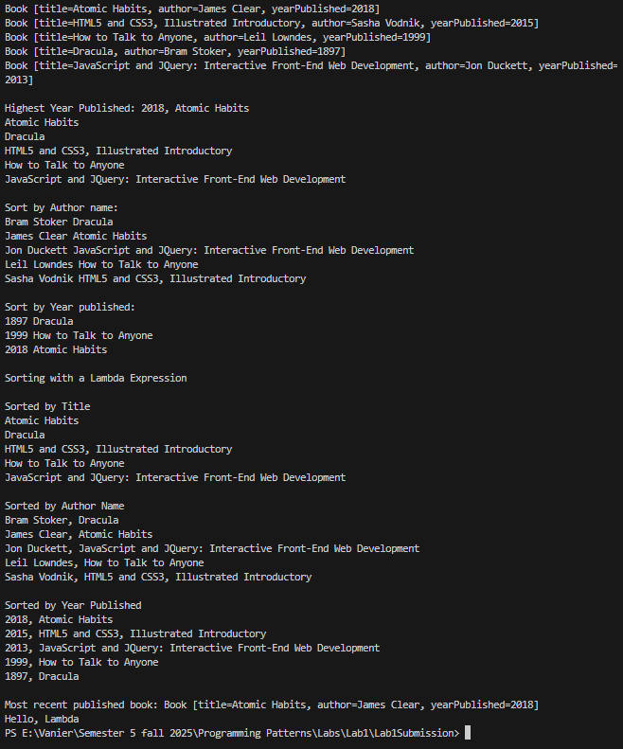

Extra
Thinking Exercise:
The key advantage of using lambda expressions is that it is faster to implement rather than creating a whole class. When compared to comparable, i believe it is similar as you just need to mention which element to be compared

Programming Exercise:
System.out.println("Most recent published book: " + book.stream().max(Comparator.comparing(Book::getYearPublished)).get());

